# Project: Analyzing a Market Test

Complete each section. When you are ready, save your file as a PDF document and submit it [here](https://classroom.udacity.com/nanodegrees/nd008/parts/11a7bf4c-2b69-47f3-9aec-108ce847f855/project).

## Step 1: Plan Your Analysis

*To perform the correct analysis, you will need to prepare a data set. (500 word limit)*

*Answer the following questions to help you plan out your analysis:*

1. What is the performance metric you’ll use to evaluate the results of your test?

Gross Margin for a single store.

1. What is the test period?

2016.4.29 – 2016.6.22

1. At what level (day, week, month, etc.) should the data be aggregated?

The data should be aggregated weekly.

## Step 2: Clean Up Your Data

*In this step, you should prepare the data for steps 3 and 4. You should aggregate the transaction data to the appropriate level and filter on the appropriate data ranges. You can assume that there is no missing, incomplete, duplicate, or dirty data. You’re ready to move on to the next step when you have weekly transaction data for all stores.*

## Step 3: Match Treatment and Control Units

*In this step, you should create the trend and seasonality variables, and use them along with you other control variable(s) to match two control units to each treatment unit. Note: Calculate the number of transactions per store per week to calculate trend and seasonality.*

*Apart from trend and seasonality...*

1. What control variables should be considered? Note: Only consider variables in the RoundRoastersStore file.

Region, monthly sales and square feet.

1. What is the correlation between your each potential control variable and your performance metric?

We expect that the monthly sales is perfectly correlated to gross margin. However, sqft seems not correlated to the gross margin.

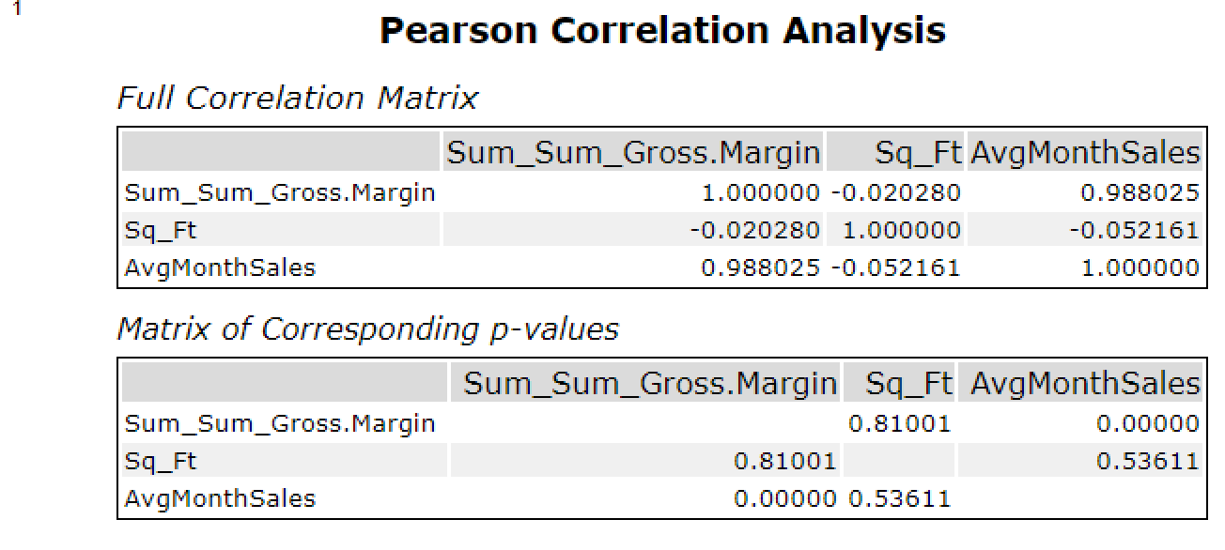

1. What control variables will you use to match treatment and control stores?

We match the treatment and control stores by trend, seasonality and avgMonthlySales

1. Please fill out the table below with your treatment and control stores pairs:

|  |  |  |
| --- | --- | --- |
| Treatment Store | Control Store 1 | Control Store 2 |
| 1644 | 7162 | 8112 |
| 1675 | 1580 | 1807 |
| 1696 | 1964 | 1863 |
| 1700 | 2014 | 1630 |
| 1712 | 8162 | 7434 |
| 2288 | 9081 | 2568 |
| 2293 | 12219 | 9524 |
| 2301 | 3102 | 9238 |
| 2322 | 2409 | 3235 |
| 2341 | 12536 | 2383 |

## Step 4: Analysis and Writeup

*Conduct your A/B analysis and create a short report outlining your results and recommendations. (250 words limit)*

*Answer these questions. Be sure to include visualizations from your analysis:*

1. What is your recommendation - Should the company roll out the updated menu to all stores?

The company should roll out the update menu. We can see from the result that the treatment groups have significantly more weekly gross margin than their control pairs. There is a 32% percent lift with 99.9% confidence for the gross margin. We can also clearly see from the time comparison plot that there are significant difference between the control and treatment stores.

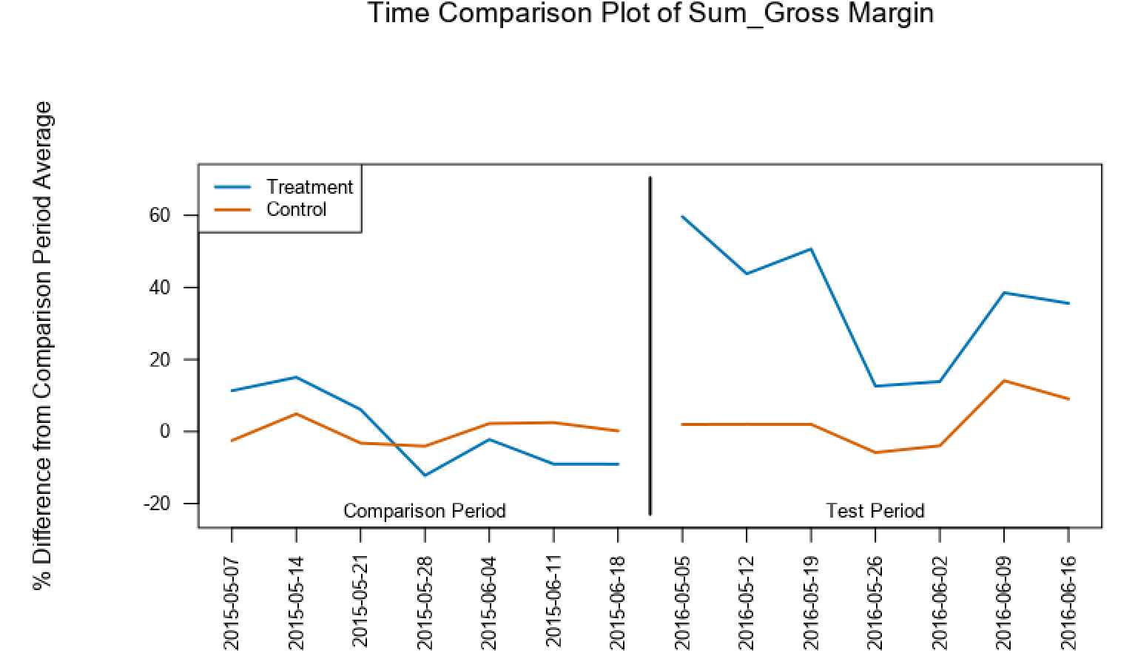

1. What is the lift from the new menu for West and Central regions (include statistical significance)?

**West**

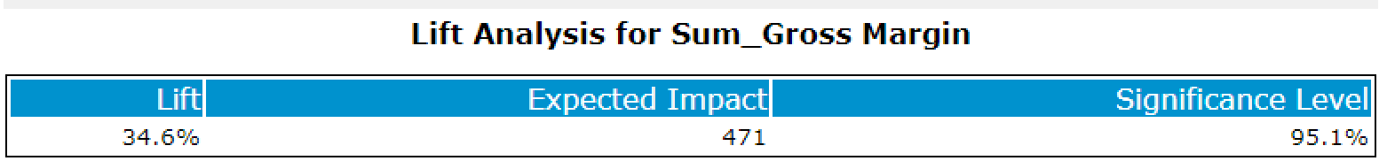

**Central**

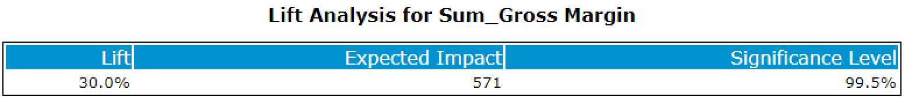

1. What is the lift from the new menu overall?

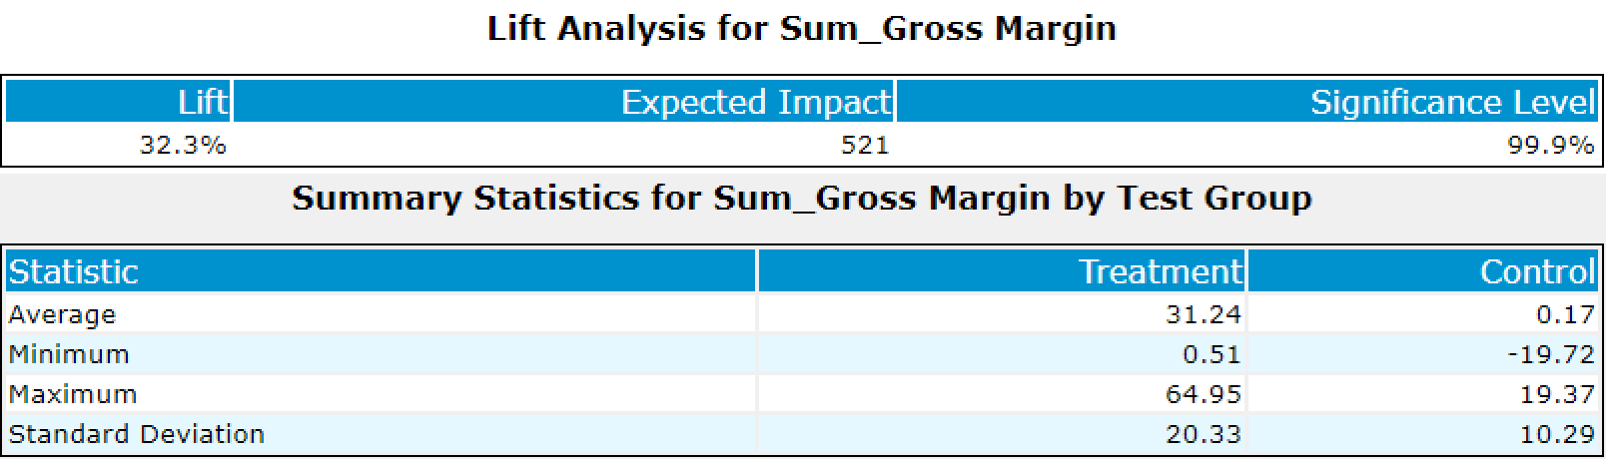

## Before you Submit

Please check your answers against the requirements of the project dictated by the [rubric](https://review.udacity.com/#!/rubrics/287/view) here. Reviewers will use this rubric to grade your project.